Value Object Model
# Source: AI Source: Provided by: [Data Path: Persons Table -> ID Column: 1, Name_En Column: Motasem Essam] -> From: [ChatGPT] on [1/23/2026]
A Value Object Model represents objects that are defined only by their values, not by identity.
👉 If two objects have the same values → they are considered equal

🔑 Key Characteristics
# Source: AI Source: Provided by: [Data Path: Persons Table -> ID Column: 1, Name_En Column: Motasem Essam] -> From: [ChatGPT] on [1/23/2026]
- ❌ No unique ID
- ✅ Compared by value
- ✅ Usually immutable (cannot change after creation)
- ✅ Represents a concept or measurement

🧱 Example
# Source: AI Source: Provided by: [Data Path: Persons Table -> ID Column: 1, Name_En Column: Motasem Essam] -> From: [ChatGPT] on [1/23/2026]
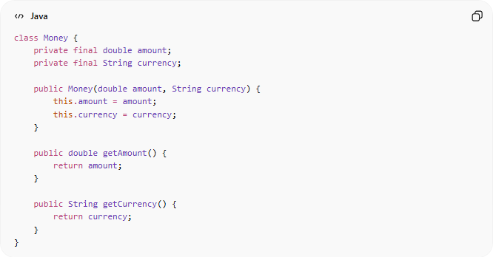
class Money {
private final double amount;
private final String currency;

public Money(double amount, String currency) {
this.amount = amount;
this.currency = currency;
}

public double getAmount() {
return amount;
}

public String getCurrency() {
return currency;
}
}

🔄 Equality Example
# Source: AI Source: Provided by: [Data Path: Persons Table -> ID Column: 1, Name_En Column: Motasem Essam] -> From: [ChatGPT] on [1/23/2026]
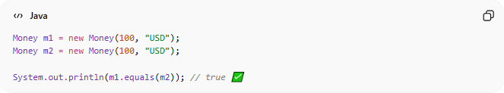
Money m1 = new Money(100, "USD");
Money m2 = new Money(100, "USD");

System.out.println(m1.equals(m2)); // true ✅
👉 Same values → same object (logically)

❌ Bad Example (Mutable Value Object)
# Source: AI Source: Provided by: [Data Path: Persons Table -> ID Column: 1, Name_En Column: Motasem Essam] -> From: [ChatGPT] on [1/23/2026]
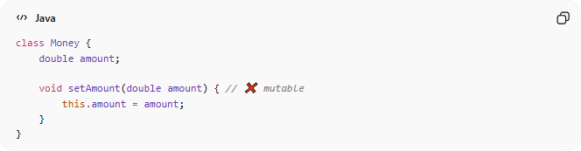
class Money {
double amount;

void setAmount(double amount) { // ❌ mutable
this.amount = amount;
}
}
👉 Problems:
- Can change unexpectedly
- Hard to track state
- Breaks value-based equality

✅ Good Example (Immutable Value Object)
# Source: AI Source: Provided by: [Data Path: Persons Table -> ID Column: 1, Name_En Column: Motasem Essam] -> From: [ChatGPT] on [1/23/2026]
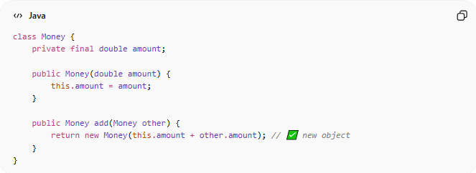
class Money {
private final double amount;

public Money(double amount) {
this.amount = amount;
}

public Money add(Money other) {
return new Money(this.amount + other.amount); // ✅ new object
}
}
👉 Benefits:
- Safe and predictable
- Thread-safe
- Easy to reason about

🔄 Value Object vs Entity
# Source: AI Source: Provided by: [Data Path: Persons Table -> ID Column: 1, Name_En Column: Motasem Essam] -> From: [ChatGPT] on [1/23/2026]

Feature | Value Object | Entity
Identity | ❌ No | ✅ Yes
Equality | By value | By ID
Mutability | ❌ Immutable | ✅ Mutable
Example | Money, Date | User, Order

🔄 Real Examples
# Source: AI Source: Provided by: [Data Path: Persons Table -> ID Column: 1, Name_En Column: Motasem Essam] -> From: [ChatGPT] on [1/23/2026]
- Money (amount + currency)
- Address (city, street, zip)
- Coordinates (x, y)
- Date/Time

⚠️ Common Mistakes
# Source: AI Source: Provided by: [Data Path: Persons Table -> ID Column: 1, Name_En Column: Motasem Essam] -> From: [ChatGPT] on [1/23/2026]
- Adding IDs to Value Objects ❌
- Making them mutable ❌
- Using them as Entities ❌

💡 Key Idea
# Source: AI Source: Provided by: [Data Path: Persons Table -> ID Column: 1, Name_En Column: Motasem Essam] -> From: [ChatGPT] on [1/23/2026]
Value Object = Value only, no identity, immutable

🧾 Summary
# Source: AI Source: Provided by: [Data Path: Persons Table -> ID Column: 1, Name_En Column: Motasem Essam] -> From: [ChatGPT] on [1/23/2026]
Value Object Model:
- Represents data defined by value
- Has no identity
- Should be immutable
- Improves safety and clarity

